PRACTICAL 5 : Temperature on LCD

Aim : To interface a 16x2 LCD with Arduino and display temperature readings.

Overview :
In this project, a temperature sensor is interfaced with an Arduino and a 16x2 LCD to display real-time temperature readings. This practical helps in learning about LCD interfacing, data communication between components, and the importance of real-time monitoring in IoT systems.

Materials Required :
- Arduino Uno R3
- 1 x 220 Ω Resistor
- LCD 16x2
- Temperature Sensor (TMP36)
- Jumper Wires
- Arduino IDE (Installed on your Computer)

Circuit Connection and Steps :
- Connect the TMP36 Temperature Sensor :
  - VCC → 5V, GND → GND, VOUT → A5 (Arduino).
- Connect the 16x2 LCD Display :
  - RS → D7, E → D8, D4-D7 → D9-D12 (Arduino).
  - VSS, RW, K → GND, VDD, A → 5V.
  - V0 → Potentiometer (Middle Pin) for contrast control.
- Connect the Potentiometer:
  - One side → 5V, Other side → GND, Middle → V0 (LCD).
- Power Connections:
  - 5V → Positive Rail, GND → Negative Rail on Breadboard.

Circuit Diagram :
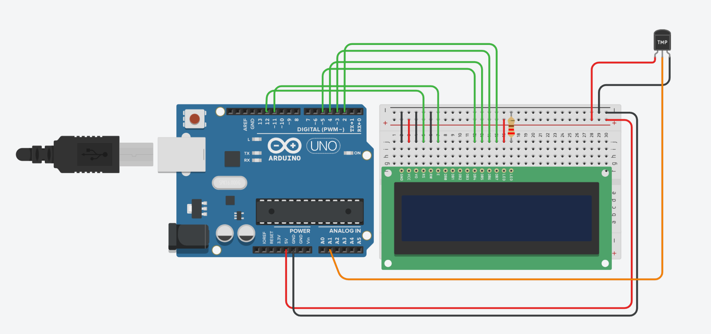
Schematic Diagram :
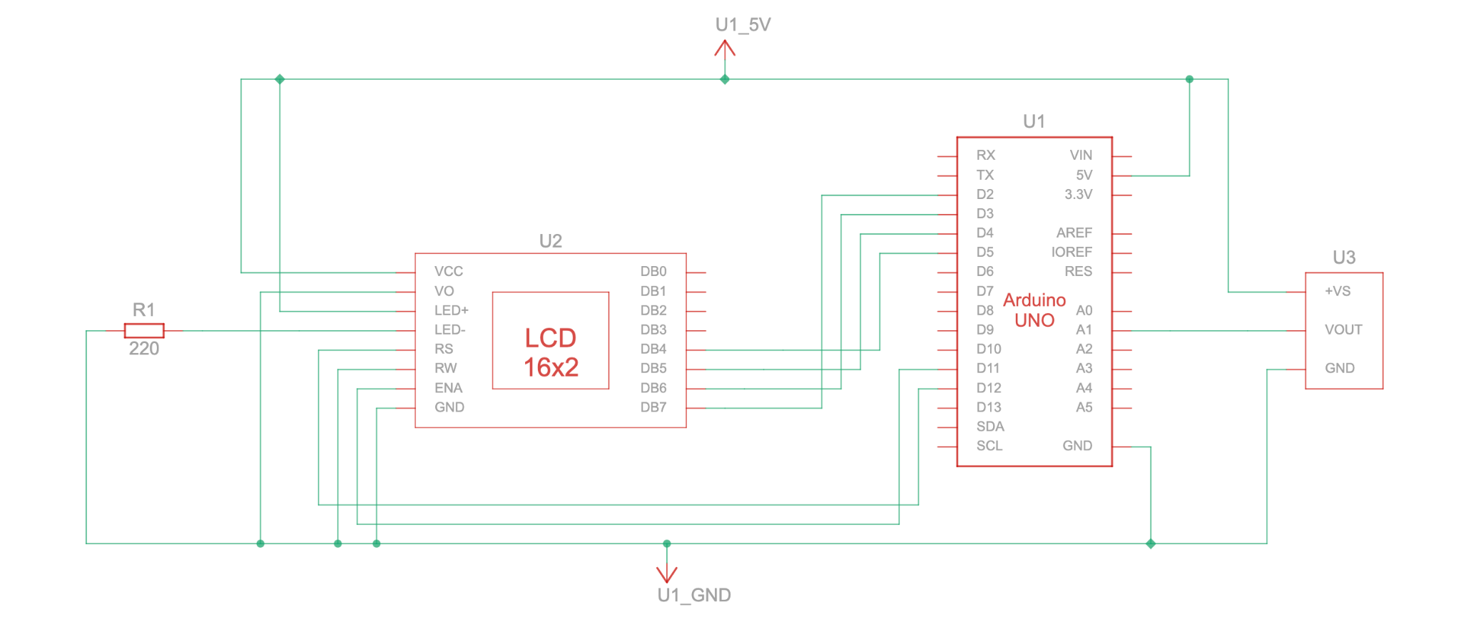
Code :
#include<LiquidCrystal.h>
const int rs = 12, en = 11, d4 = 5, d5 = 4, d6 = 3, d7 = 2;
LiquidCrystal lcd(rs, en, d4, d5, d6, d7);
float celsius;
int temp = A1;
void setup(){
pinMode(temp,INPUT);
}
void loop(){
celsius = analogRead(temp)*0.004882814;
celsius = (celsius - 0.5) * 100.0;
lcd.setCursor(0,1);
lcd.print("--> Temp : ");
lcd.print(celsius);
lcd.print(" C");
delay(1000);
lcd.clear();
}
Results :
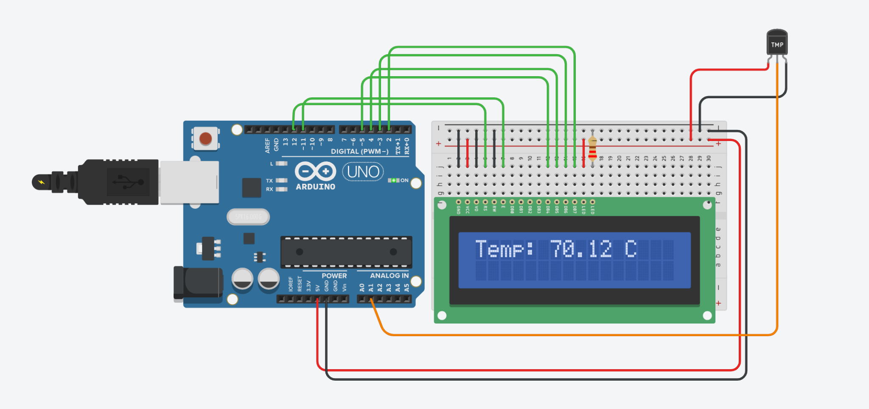
Conclusion :
This project successfully demonstrates how to interface a 16x2 LCD with an Arduino to display real-time temperature readings. It reinforces the concepts of sensor integration and data visualization, providing a crucial step toward developing more complex IoT applications involving real-time monitoring systems.

